**Các lệnh cơ bản thao tác với Docker**

1. docker –version

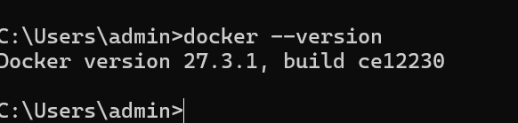

1. docker run hello-world

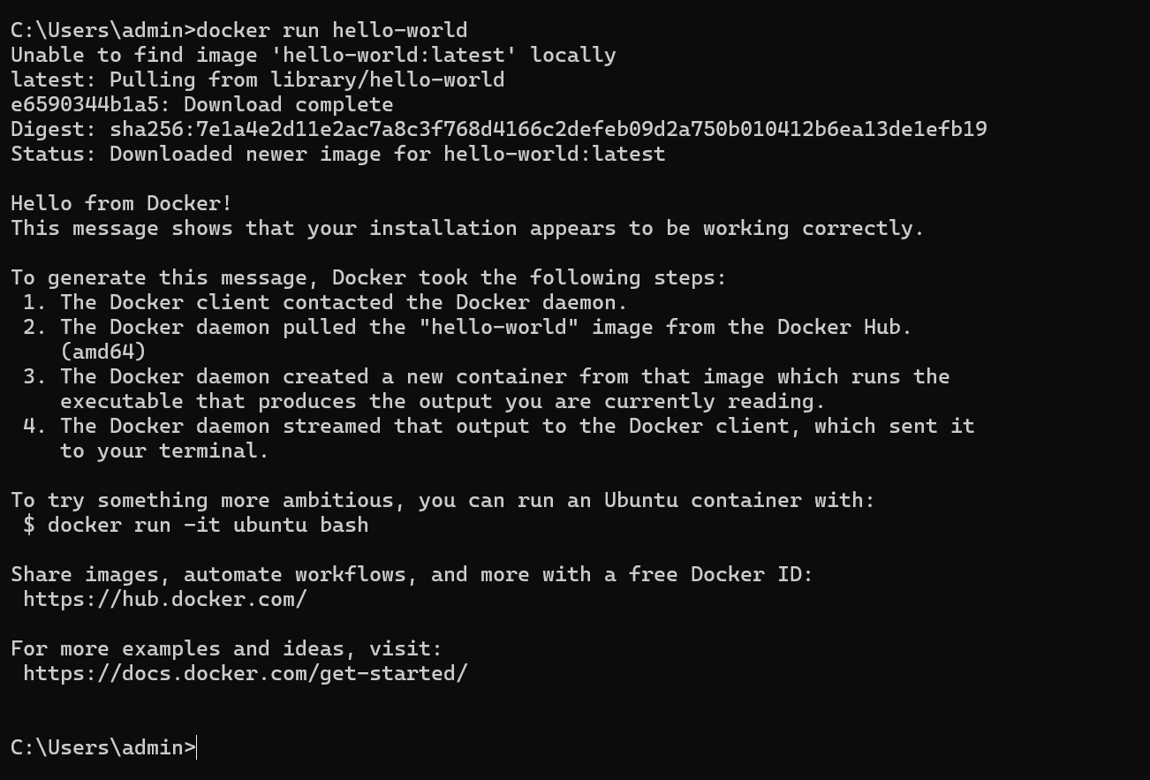

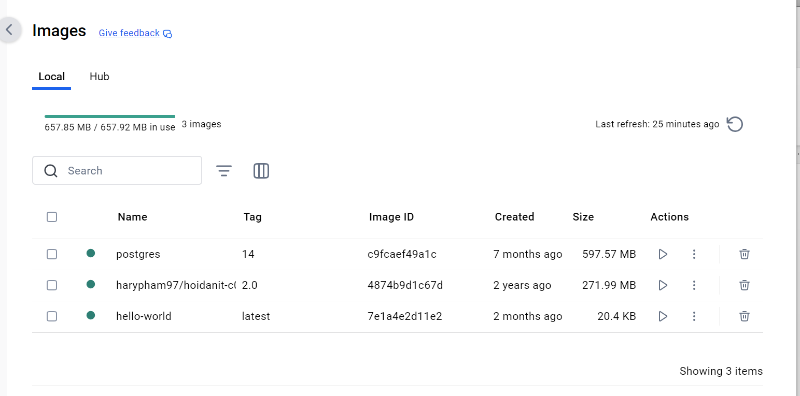

1. docker pull nginx

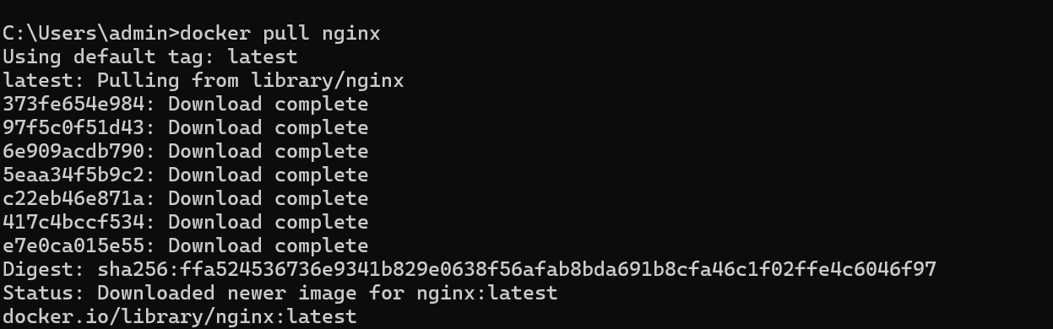

1. docker images

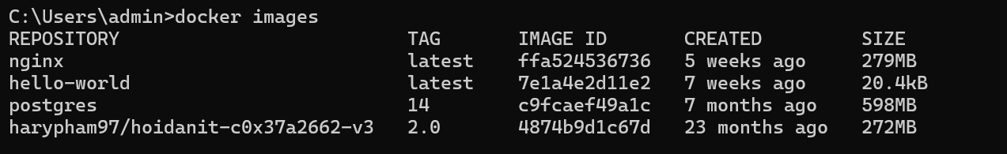

1. docker run -d nginx



1. docker ps



1. docker ps -a

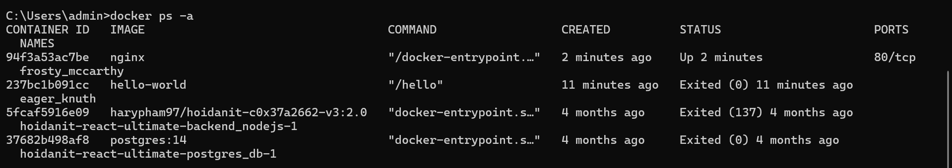

1. docker logs <container_id>

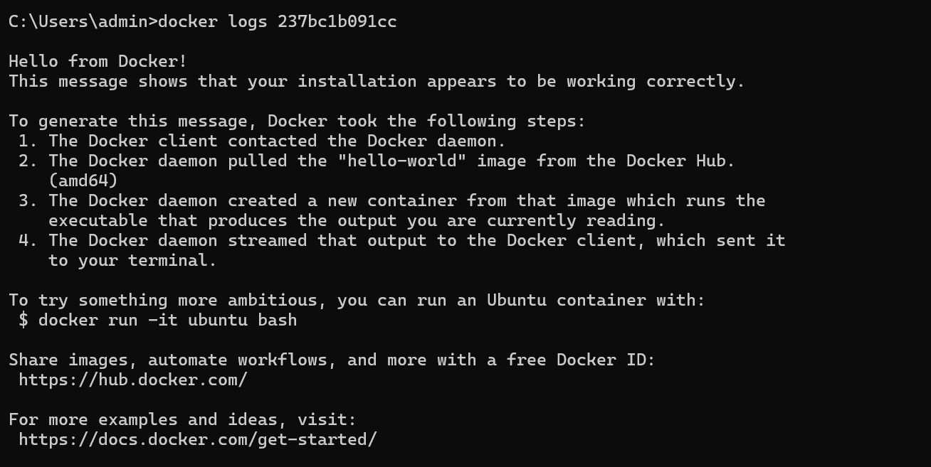

1. docker exec -it <container_id> /bin/sh



1. docker stop <container_id>

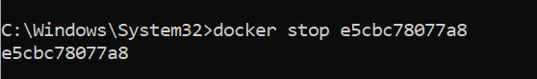

1. docker restart <container_id>



1. docker rm <container_id>



|  |
| --- |
| 1. docker container prune |
| 14.docker rmi <image_id> |
| 15.docker image prune –a |
| 16.docker run -d -p 8080:80 nginx |
|  |
| 17.docker inspect <container_id> |
| 18.docker run -d -v mydata:/data nginx |
| 19.docker volume ls |
| 20.docker volume prune |
| 21.docker run -d --name my_nginx nginx |
| 22.docker stats |
| 23.docker network ls |
| 24.docker network create my_network |
| 25.docker run -d --network my_network --name my_container nginx |
| 26.docker network connect my_network my_nginx |
| 27.docker run -d -e MY_ENV=hello_world nginx |
| 28.docker logs -f my_nginx |
| 29.FROM nginx |
| COPY index.html /usr/share/nginx/html/index.html |
| 30.docker build -t my_nginx_image . |
|  |
| 31.docker run -d -p 8080:80 my_nginx_image |

